**UVA CLINICAL FACULTY MEDICAL CENTER RELATED ACTIVITIES REPORTING**

1. Access Payroll Allocation Confirmation (PAC) System for your certification through the email you received or by going directly to the PAC System environment at <https://pac.virginia.edu/ecc/>
2. Log into the application through SSO and using your UVA username/password.

1. You are viewing the Home Page. The Home Page will display your Worklist. The Worklist displays three sections:
   1. Payroll Statements
   2. Grant Statements
   3. Associated Grant Statements

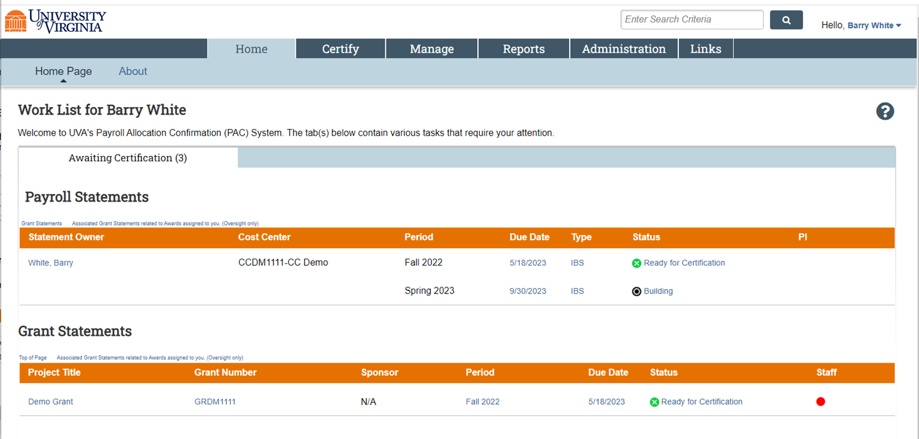

1. You are required to to submit a Medical Center Related Activities Report on a semi-annual basis.
2. To access your Payroll Statements for certification and Medical Center Related Activities Reporting, click on the link associated to the  line under Payroll Statements.

1. The Payroll Statement
   1. is split into two or three sections, Sponsored (if you are paid by a Sponsored Grant), Non-Sponsored, and UPG.
   2. lists all payroll dollars, salary-over-the-cap (SOC), and cost share dollars, for each grant or activity that has salary charges, for the reporting period.

1. On the Payroll Statement, review all grants, payroll dollars, salary-over-the-cap (SOC), and cost share dollars for accuracy.
   1. Your Cost Center Payroll Reporting Coordinator (PRC) has already reviewed your statement and it should be accurate. If you have questions about your statement, you can click the ‘Get Help’ button to email your PRC about any issues you may be having (ensure that all pop-up blockers are turned off).



1. To begin your Medical Center Related Activities Report
   1. Click on the search bar and a list of categories will appear.
      1. Click the search bar again to hide the list of categories.
   2. Begin typing the name of the category that corresponds to that activity. The lookup search will narrow the list as you type.
   3. Note: The activities for Direct Patient Care, Instructor for Resident/Fellows/Trainees, and Administration of Residency/Fellowship Programs are now listed in the list of categories.

1. Your PRC may have used a place holder for your categories and percentage using “0-Academic Activity, Not Reportable.”
   1. ***Please be sure to update the appropriate categories and % relevant to the NSP or UPG Activity.***
   2. To remove a category line, enter “0%” and the line will be removed when you save (and refresh your web browser) or certify.

1. Enter categories and percentages of time that corresponds to that category for each activity.
   1. The sum of the percentages entered for all categories listed under an activity must total the Computed Payroll % for that activity.

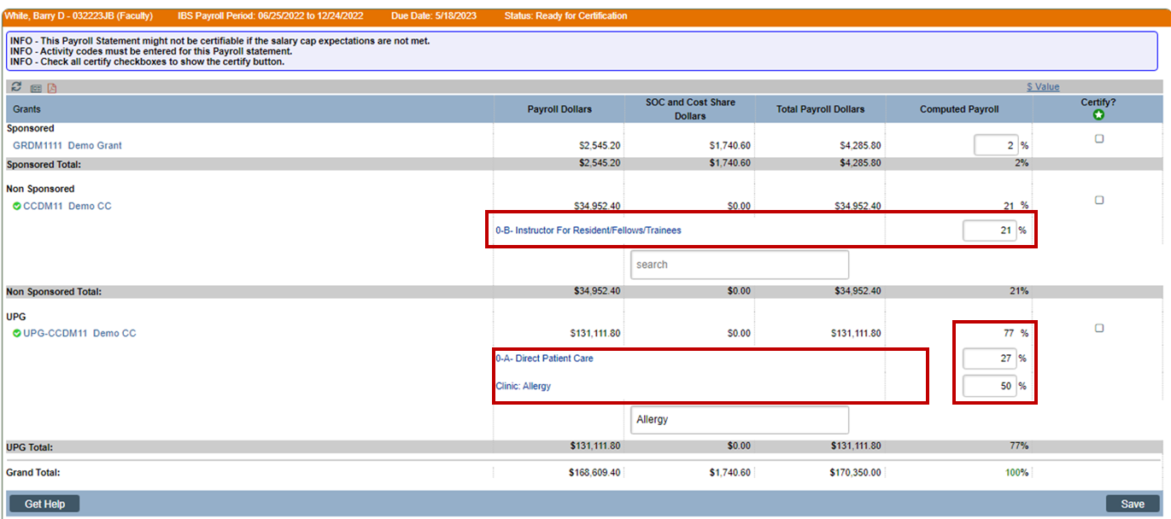

1. If you wish to save your progress, select each line you wish to save and click the ‘Save’ button to return to complete your review process at a later time.
   1. To view the original percent on an activity line, you can click the reset button at the top right corner of your PAC statement.

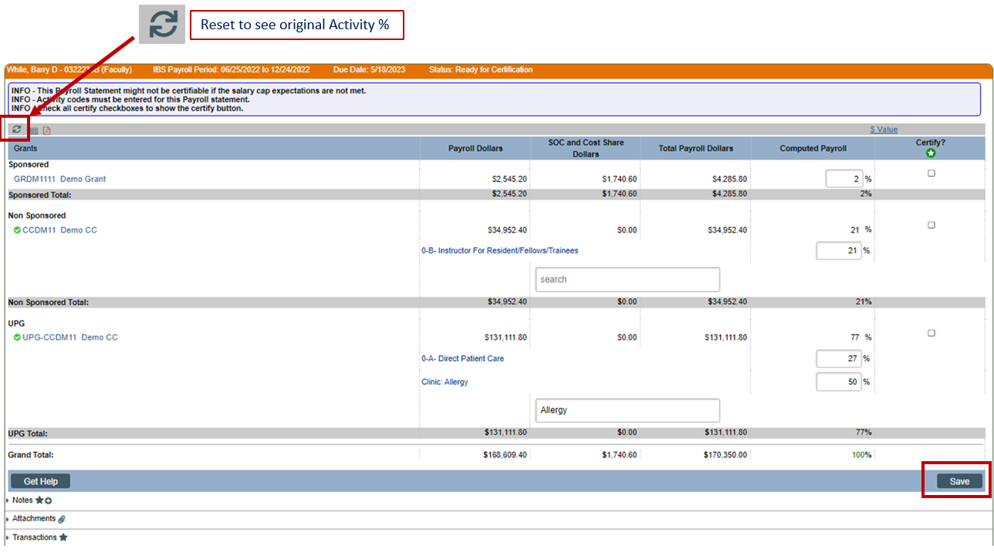

1. You are required to enter the average number of hours worked per week during this period.
   1. Click ‘Submit Hours.’

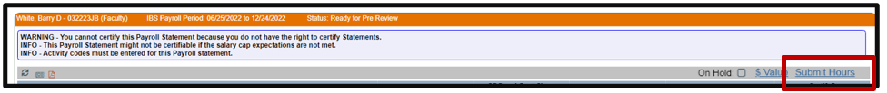

* 1. Enter the average number of hours worked. You can enter a decimal value or whole number.
  2. Click ‘Close.’

**Note:** The ‘Submit Hours’ link will not appear once the statement is in the ‘Certified’ State. You will need to contact the [MCR Admin](mailto:CLMedicalCenterRelatedActivitiesReporting@hscmail.mcc.virginia.edu?subject=Please%20Edit%20Average%20Hours%20Worked) to edit the Hours.

* 1. If the ‘Certify’ button is clicked before hours have been submitted you will get the following pop up:

1. To certify the entire Payroll Statement:
   1. Select the individual check boxes under the ‘Certify’ column or select the green star , which is a ‘Check All’.
   2. Select the ‘Certify’ button which has now appeared.

1. Select ‘OK’ in the pop-up box which has now appeared.

1. Review the attestation statement and select ‘I Agree’ to complete the certification. Text

   Description automatically generated
2. Your Payroll Statement and Medical Center Related Activities Reporting is complete and has been removed from your Worklist.